Coursework 2 Report

CIS4514 Programming for Data Science & Artificial Intelligence
Hafeez Ullah Amin
Kate Forshaw
25259628

Word count: 2615

Task 1
For the first task, it was required to examine reviews of video games available on Amazon and discover the ten most popular games, and the ten least popular games. This had to be completed through creating a software on a virtual machine (VM), which should automatically analyse the dataset of Amazon video game reviews.
The Cloudera VM software chosen for this task was Hive (see appendix 1). Hive is a system that outlines, queries, and evaluates large, distinct data sets, and it can be referred to as a data warehouse (Cloudera, 2025). It was implemented as databases can be created within it, emphasising tables may be defined which allows Hive to load data from CSV into the corresponding defined fields (Ronianto et al., 2019). This demonstrates that Hive supports query language (Goodarzi et al), insinuating queries can be designed to investigate the reviews and popularity of Amazon’s video games.
A database was created and named video_games (see appendix 2). It then had to be stated to use that database (see appendix 3). A table called reviews was created with three columns: rating as a decimal (2,1) datatype, game_id as varchar (10), and comment also as varchar (1000) (see appendix 4). There was a ‘row format delimited fields terminated by’ statement within the query to establish that the imported dataset was organised in rows, consisting of multiple pieces of data (IBM, 2025). The dataset of reviews of Amazon’s video games was loaded into the table reviews (see appendix 5). To check if all the data was imported, a select query was written to count the total number of reviews, the result was accurate with 40,000 (see appendix 6).
It was necessary to compute the top ten video games with the highest number of 5-star reviews. A query was designed to select game_id and count the number of reviews where rating equalled 5.0, referred to as and ordered by five_star_reviews descending with a limit of 10 games (see appendix 7). This presented the ten games with the highest total of 5-star reviews, for example, the most popular game was B004MC8CA2 with 1605 ratings that were five stars.
Another requirement was to measure the top ten video games with the highest number of 1-star reviews. A query was designed to select game_id and count the number of reviews where rating equalled 1.0, referred to as and ordered by one_star_reviews descending with a limit of 10 games (see appendix 8). This presented the ten games with the highest total of 1-star reviews, for example, the least popular game was B00409G750 with 78 ratings that were one star.
Some additional queries were ran that may be of interest for Amazon’s Research and Development team. They may want to discover the average rating of all games or a specific game. Game_id was selected along with the average function being applied to rating, for the game B004LZOTHU, which printed a result of 3.19 rating average (see appendix 9). To view the average ratings of all the video games, remove the ‘where’ statement, and they will be presented from highest average to lowest via the ‘order by’ statement.
Another method of accessing rating stats for the video games could be through calculating the distribution of ratings. Rating was selected and counted where game_id was B004K5K92K, which demonstrated this game had 9 one-star reviews, 7 two-stars, 10 three-stars, 10 four-stars, and 19 five-stars (see appendix 10). This query was designed for a specific game again, but could relay the distribution of ratings amongst all games by removing the ‘where’ statement.
Amazon may like to know which games had the greatest number of reviews. Game_id was selected and counted for all its reviews, referred to and ordered by as total_reviews descending, with a limit of 10 games (see appendix 11). This portrayed a list of the top ten games with the greatest number of reviews, for example, the game B004MC8CA2 had the highest review total with 2041. If the games with the lowest review totals was of interest, the ‘order by’ statement would need to be converted to ascending, rather than descending.
The Research and Development team may want to view the volume of reviews alongside the average ratings for each game. Game_id was selected and counted – as total_reviews – and average rating was calculated – as average_rating – for the game B004S7XGKW (see appendix 12). This indicated the video game had a total of 5 reviews and an average rating of 2.8 stars. This query could present all video games’ total reviews and average ratings altogether if the ‘where’ statement was removed.
It could be intriguing to discover if there are Amazon video games that have contradicting reviews with a lot of five-star and one-star ratings. Selected was game_id, the sum of ratings equalled to 1 as one_star, and the sum of ratings equalled to 5 as five_star, where both one_star and five_star are more than 50 and ordered by descending, with a limit of 10 (see appendix 13). This proposed a list of the top ten games with the most polarised reviews, for example, the game B004MC8CA2 had 1605 5-star ratings, but also many 1-star ratings (70).
Task 2
After cleaning and reducing the Road Safety Data 2021, it was combined with the metadata to convert meaningless numeric codes to descriptive accident characteristics. This allowed for the visualisation of the accident data to be understood and interpreted more accurately.
A bar chart was plotted to represent number of accidents by collision severity across different road types (see figure 1). It appeared that a single carriageway was more accident prone, especially when the collision was slight. According to the UK Government statistics (2021), A and minor (B, C, and unclassified) roads covered 99% of road length and accounted for 80% of total vehicle miles in 2021. With the vast majority of A, B, and C roads being single carriageways, this implies that accidents were more likely to occur in single carriageways as they were the most common road type and most frequently used. Additionally, slight severity prevailed, followed by serious, then fatal for every road type, which likely would have been the favourable outcome.
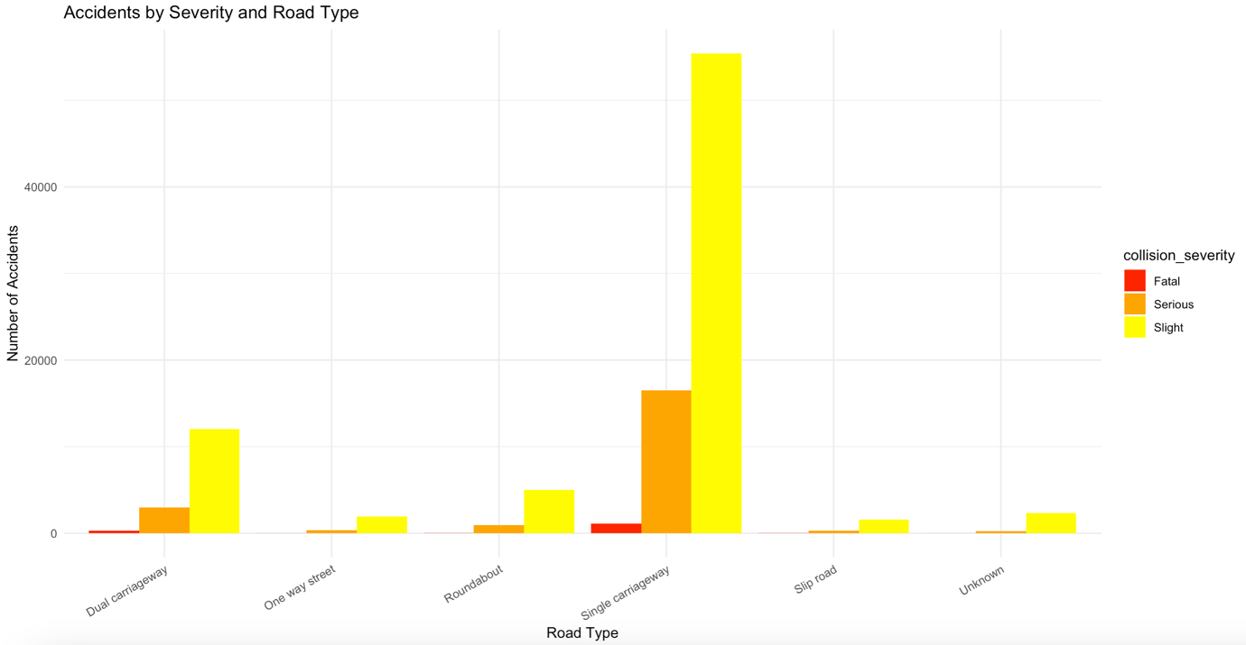
Figure 1 Bar chart representing accidents by severity and road type
The creation of a scatter plot was required for the relationship between weather conditions, road surface, and accident frequency (see figure 2). This demonstrated that accident count was high when the roads were dry and the weather was fine with no high winds. The accident count was moderate when the road surface was wet or damp and when the weather was fine or raining with no high winds. The remaining accident counts for road surface and weather conditions were fairly low. Pinskwar et al. (2023) found that risk of accidents grew when associated with conditions that were a “good weather for a ride”. This suggests that when the weather is normal or nicer, more people are out and driving about, therefore, increasing the likelihood of an accident.
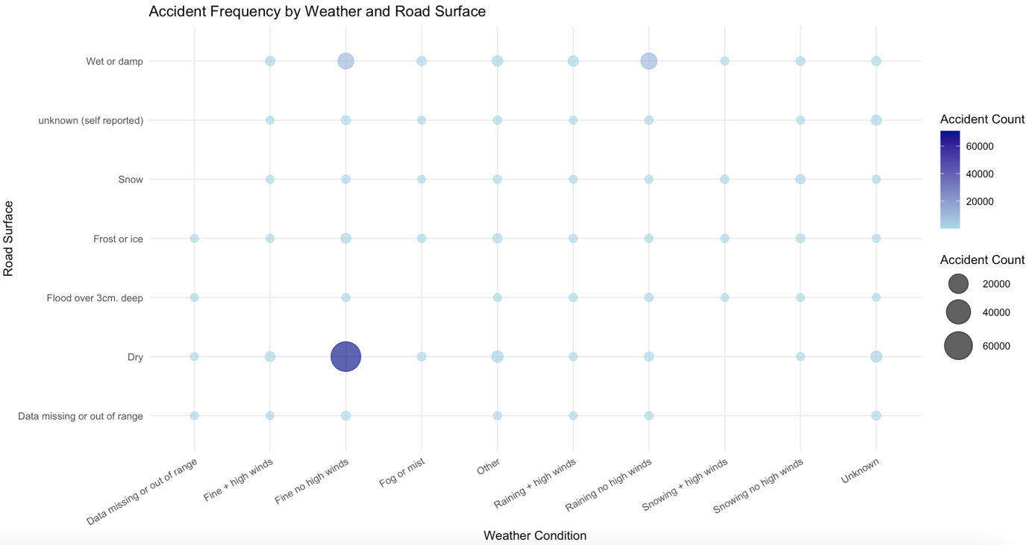
Figure 2 Scatter plot representing accident frequency by weather conditions and road surface
A dot map demonstrating accident density in Greater Manchester was created (see figure 3). This dot map contains every accident that took place in Greater Manchester in 2021. The approximate coordinates with the most concentration of dots was (-2.25, 53.475), which corresponds to Manchester city centre potentially being the area with the highest accident density. The city centre usually has the highest population in Greater Manchester – in 2021, it was 551,953, compared to the second highest which was significantly lower at 329,329 (GMCA, 2023). This insinuates that the higher the population of an area in Greater Manchester, the more accidents that are likely to occur.
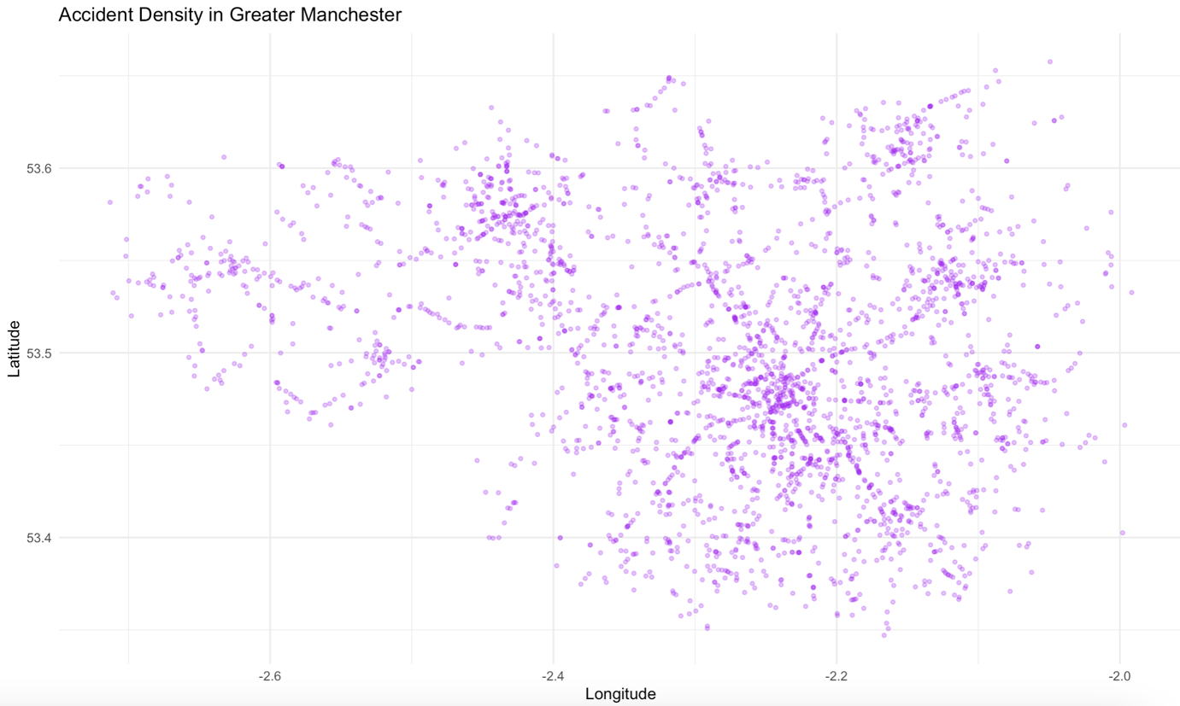
Figure 3 Dot map representing accident density in Greater Manchester
There was a requirement to plot a heatmap or a dot map for Greater Manchester, so a heatmap was represented for accident density in Devon and Cornwall instead (see figure 4). The most concentrated area – portrayed by the darkest point on the heatmap – was the approximate coordinates (-4.2, 50.38), which refers to the town of Plymouth. Plymouth is the largest city in Devon and is right on the boarder of Cornwall, all while being a major waterfront city and urban hub by securing one of the greatest variety of shops (Visit Plymouth, 2025). Due to it being the most urban and central area in Devon and Cornwall, this could be a contributing factor to why the most accidents take place there.
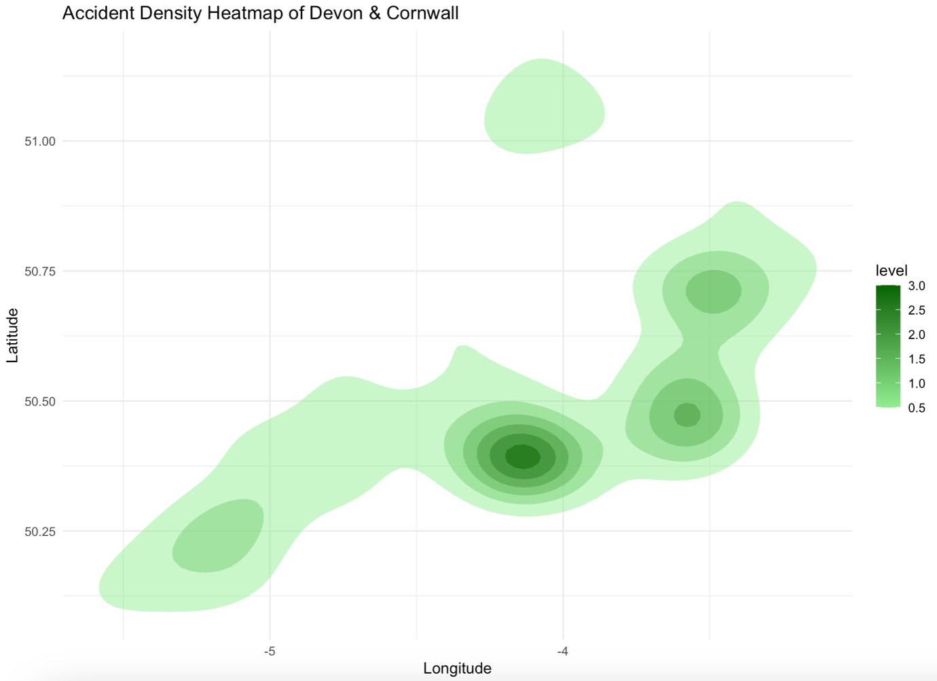
Figure 4 Heat map representing accident density in Devon and Cornwall
It was of interest to discover if there was a relationship between number of casualties and number of vehicles for all the road collision data. Therefore, a line chart was plotted based on the average number of casualties by the number of vehicles involved (see figure 5). This line chart portrayed that the lowest casualty average was 1 with 12 and 13 vehicles being involved – the greatest numbers of vehicles recorded. This was surprising as it infers that there was a potential negative relationship between average casualties and vehicle numbers. However, casualty average was at its highest point at approximately 2.625 when 8 vehicles were involved, and its second lowest point of 1.125 with also the least vehicle involvement of 1. This suggests that a moderate number of vehicles involved in an accident could cause more harm than a significantly small or large number of vehicles.
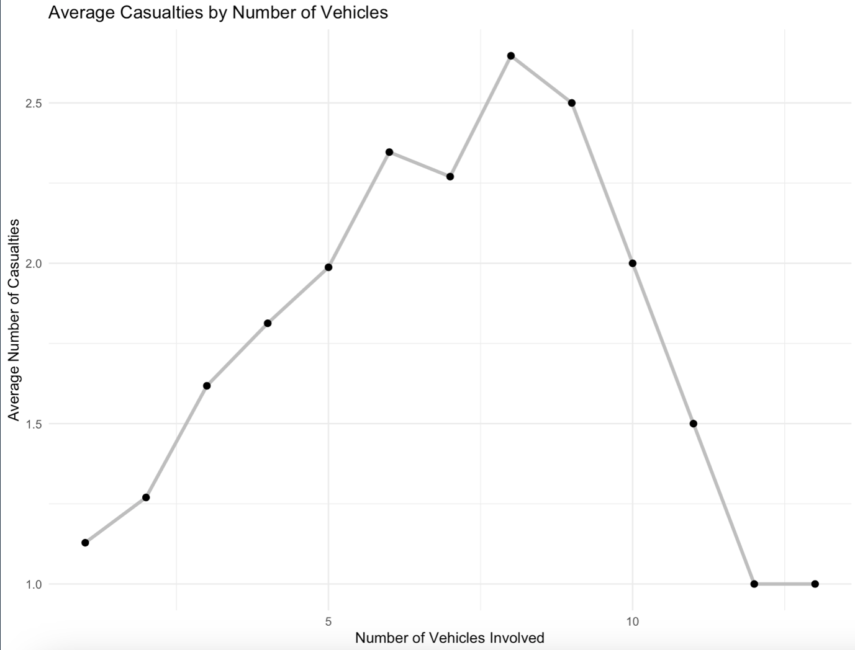
Figure 5 Line chart representing average casualties by number of vehicles

Task 3
For this task, it was required to create an R Shiny interactive dashboard based upon the Road Safety Data 2021. This had to include the accidents dataset alongside either the vehicle or casualty datasets. It was chosen to combine accidents with vehicles, to discover if specific vehicle properties were at fault for the collisions, and if there were any patterns unveiled between vehicles and accidents.
The road accident dataset was loaded into R and inspected using glimpse, summary, and head. Glimpse demonstrated the name, datatype, and first few values of each column, for example, speed limit was a column with integers, which most of the first values were 30 (mph), apart from the third row was 40 (see appendix 14). Summary calculates the minimum, 1st quartile, median, mean, 3rd quartile, and maximum of each integer column. Latitude obtained a mean of 52.36, with the lowest value of 49.98, the highest was 60.5, the coordinate in the centre of all rows was 51.79, 51.46 was halfway in-between the minimum and median, and 53.33 was halfway between the medium and maximum (see appendix 15). Head highlights the first 6 rows of each column, for example, the first six local authority highways presented were E06000001, E06000002, E06000002, E06000003, E06000005, and E06000007 (see appendix 16).
Following this, the road accident dataset was pre-processed through cleaning the names of columns, removing rows with missing values, removing duplicate rows or columns, and removing unnecessary columns. The columns deleted were collision_year, collision_ref_no, location_easting_osgr, location_northing_osgr, local_authority_district, local_authority_highway, first_road_class, first_road_number, second_road_class, second_road_number, pedestrian_crossing_human_control_historic, pedestrian_crossing_physical_facilities_historic, carriageway_hazards_historic, trunk_road_flag, lsoa_of_accident_location, collision_adjusted_severity_serious, and collision_adjusted_severity_slight. Reasons for these being removed were due to repetitive information, updated information, or simply not required information for trends and insights of interest.
The vehicle dataset was loaded and followed the same process. In glimpse, age of driver was an integer, ten of which were 86, 23, 27, 70, 42, 32, 37, 41, 54, and 4 (see appendix 17). The summary stated age of vehicle had a minimum of -1, 1st quartile of 0, median of 5, mean, of 6.001, 3rd quartile of 11, and a maximum of 91 (see appendix 18). The head presented the first 6 values of engine capacity cc to be 6200, 124, 124, 1968, 1968, and 1798 (see appendix 19). Cleaning the vehicle dataset involved removing collision_year, vehicle_manoeuvre_historic, vehicle_location_restricted_lane_historic, journey_purpose_of_driver_historic, escooter_flag, and driver_distance_banding.
Vehicles were left joined to accidents, so there was one row per vehicle with accident details added. This prevented accidents having duplicated rows. The road safety metadata was obtained, cleaned, and joined to the accident and vehicle combined data to convert meaningless numbers to descriptive labels.
Metrics were created for vehicle types: car, motorcycle, bus, HGV, bike, tractor, tram, mobility scooter, and other. The metrics for vehicle manoeuvre were reversing, parking, waiting, stopping, moving forward, turning, changing lane, overtaking and unknown. Metrics were designed for no skidding, skidded, overturned, jack-knifed, did not hit object and did hit object. Age of driver and vehicle consisted of metrics young driver, middle-aged driver, old driver, old car, and young car. Metrics were also created for propulsion code: petrol, oil, electric, steam, gas, diesel, and other. All the new metrics were inspected through head (see appendix 20). They were produced to help the filtering process for the interactive dashboard.
Before building the interactive dashboard, the column hour had to specified as numeric as a problem was faced when plotting its values due to its datatype being character. Additionally, a function was designed to calculate the mode of data, which could later be implemented for summary tables.
To build the dashboard, a server had to be implemented. A function was created inside the server to filter the accident vehicle metrics data, so the dashboard would be re-run whenever a filter is altered by a user. The filters chosen were based solely on the metrics created earlier – all based on vehicle characteristics and components. These included vehicle type, manoeuvre, junction location, skidding, hit object, age of driver, age of vehicle, and propulsion.
Tables and graphs were inputted onto the server concerning accident characteristics such as severity, time, weather conditions, and location. The tables were reactive meaning they would change relative to the vehicle filters selected. Whereas, the graphs were reactive and interactive, which allows for insights and representations of points on a graph when hovered over. There was a summary table which provided the total number of crashes, and the mode severity, hour, weather, and local authority district (LAD). The visualisation of the summary table was a lollipop chart representing the mode values, where each mode plotted was assigned a corresponding colour to its individual graphs. There was an individual table created for each of severity, time, weather, and LAD, which contained the count and percent for their distinct variables. A tree map was acquired to plot severity, with red representing fatal, orange for serious, and yellow for slight. The plot for time was a bar chart where each (purple) bar expressed an hour in the day from 0-23. Weather conditions were plotted on a horizontal bar chart in light sky blue. A scatter plot was designed for location, consisting of longitude and latitude coordinates plotted in forest green, to see specifically where in the UK the collision took place.
Following the server set-up was the user interface. This defines what the user views and interacts with. A clean, modern theme called ‘flatly’ was chosen for the dashboard, and it was given a title of ‘UK Collision Trends & Insights 2021’. The sidebar was filled with all the possible filters that could be selected. The main panel had five tabs: overview, severity, time, weather, and location. Overview contained the summary table and lollipop plot; severity contained the severity tree map and breakdown table; time contained the hour bar plot and breakdown table; weather contained the weather bar chart and breakdown table; and location contained the longitude and latitude scatter map and LAD breakdown table. The interactive dashboard was then ready to be ran.
This interactive dashboard should portray patterns between accident characteristics (severity, time, weather, and location) and vehicle characteristics (type, manoeuvre, junction location, skidding, hit object, age of driver, age of vehicle, and propulsion) involved in a crash. It was a requirement to represent location by regions in the UK, however, there was difficulty faced. There were several attempts to join region name datasets from different years with the accidents and vehicle dataset, but it was not successful as the names of LADs did not accurately align between the two datasets. Therefore, location trends were sufficiently covered by both LAD and coordinates.
References
CLOUDERA, 2025. Apache Hive key features. Cloudera.com [online]. Available from: https://docs-archive.cloudera.com/runtime/7.0.3/hive-introduction/topics/hive_whats_new_in_this_release_hive.html
GOV UK, 2021. Road Safety Data – Accidents 2021. Gov.uk [online]. Available from: https://data.dft.gov.uk/road-accidents-safety-data/dft-road-casualty-statistics-collision-2021.csv
GOV UK, 2021. Road Safety Data – Vehicles 2021. Gov.uk [online]. Available from: https://share.google/mZesT4vOR5bWVN6nN
GOV UK, 2024. Road Safety Data Guide. Gov.uk [online]. Available from: https://data.dft.gov.uk/road-accidents-safety-data/dft-road-casualty-statistics-road-safety-open-dataset-data-guide-2024.xlsx
GOV UK, 2024. Road traffic estimates in Great Britain, 2024: Traffic in Great Britain by road type. Gov.uk [online]. Available from: https://www.gov.uk/government/statistics/road-traffic-estimates-in-great-britain-2024/road-traffic-estimates-in-great-britain-2024-traffic-in-great-britain-by-road-type
GOV UK, 2025. Guidance on road classification and the primary route network. Gov.uk [online]. Available from: https://www.gov.uk/government/publications/guidance-on-road-classification-and-the-primary-route-network/guidance-on-road-classification-and-the-primary-route-network
GREATER MANCHESTER COMBINED AUTHORITY (GMCA), 2023. Census 2021 Briefing – Total population. Gov.uk [online]. Available from: https://www.greatermanchester-ca.gov.uk/media/7869/230514_population_final.pdf
IBM, 2025. IBM TRIRIGA application platform. Ibm.com [online]. Available from: https://www.ibm.com/docs/en/tap/4.4.0?topic=process-tab-delimited-files
PINSKWAR, I., CHORYNSKI, A. and GRACZYK, D., 2024. Good weather for a ride (or not?): how weather conditions impact road accidents—a case study from Wielkopolska (Poland). International journal of biometeorology, 68(2), pp.317-331. Available from: https://pmc.ncbi.nlm.nih.gov/articles/PMC10794278/
RONIANTO, M.F., ASROR, I., PRABOWO, S. and NUGRAHA, F.A., 2019, March. Performance evaluation sql-on-hadoop: a case study of Hortonworks and Cloudera. In Journal of Physics: Conference Series (Vol. 1192, No. 1, p. 012016). IOP Publishing. Available from: https://doi.org/10.1088/1742-6596/1192/1/012016
VISIT PLYMOUTH, 2025. Plymouth – Britain’s Ocean City. Visit Plymouth [online]. Available from: https://www.visitplymouth.co.uk/explore/areas-to-visit/devon

Appendices
Appendix 1 Implement Hive software on Cloudera
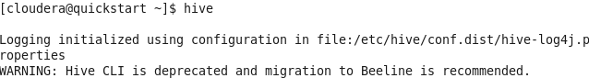
Appendix 2 Create video games database
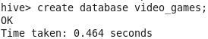
Appendix 3 Use video games database
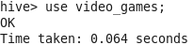
Appendix 4 Create reviews table
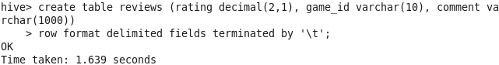
Appendix 5 Load Amazon video game reviews dataset
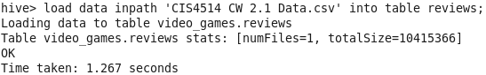

Appendix 6 Count total number of reviews
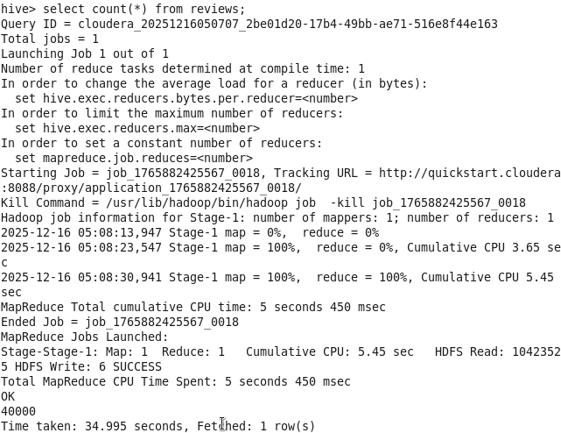

Appendix 7 Select games and count five-star reviews
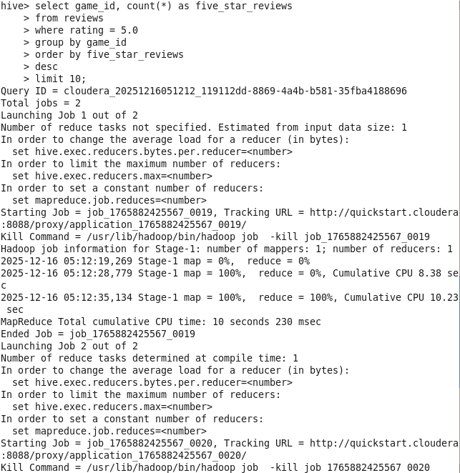
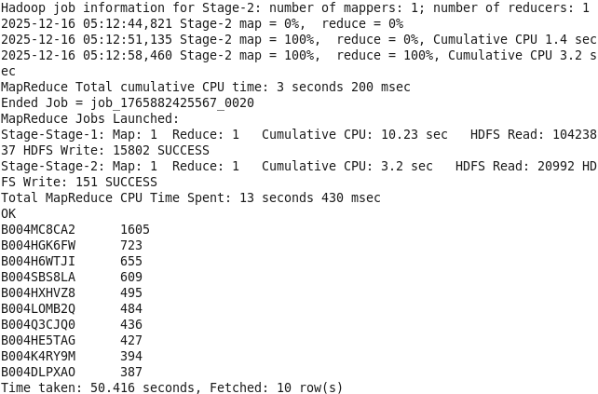
Appendix 8 Select games and count one-star reviews
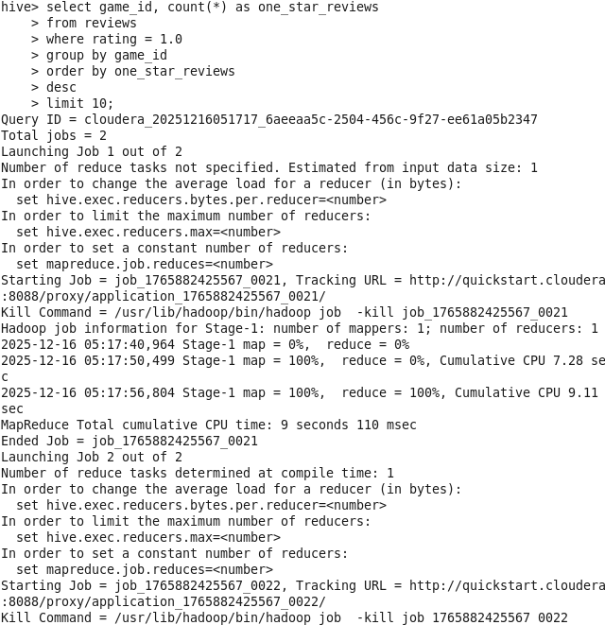
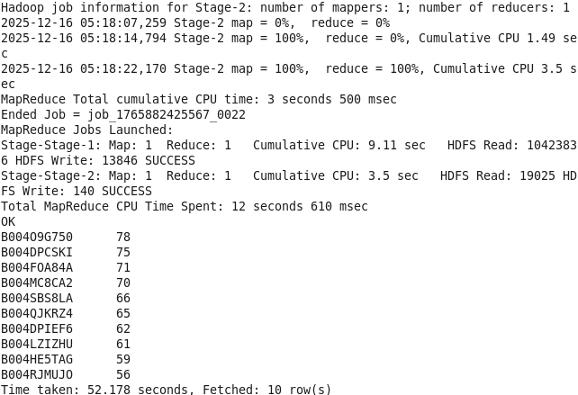
Appendix 9 Select games and average ratings
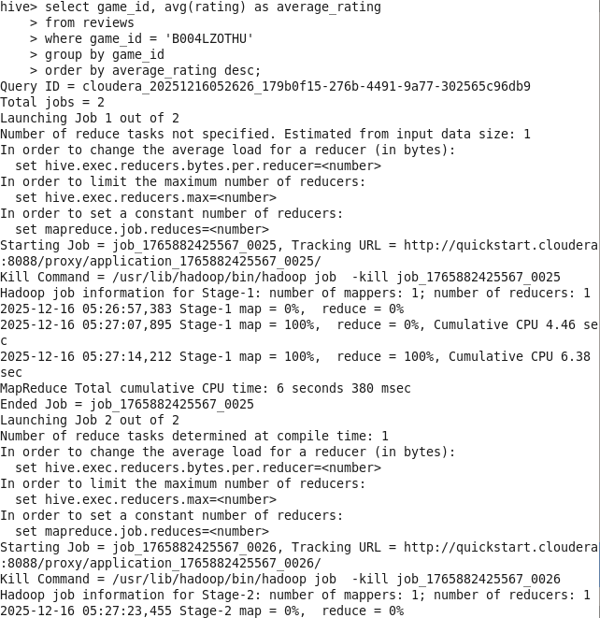
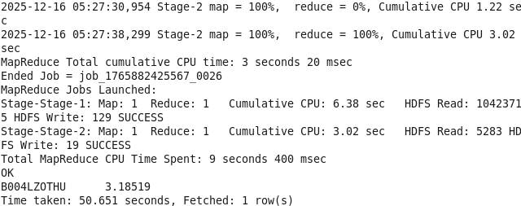
Appendix 10 Select and count ratings
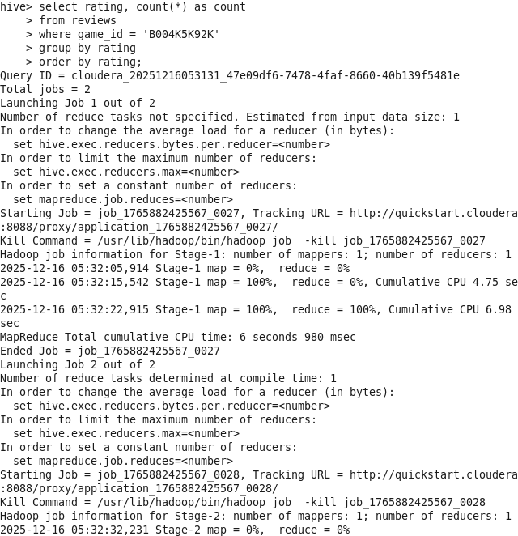
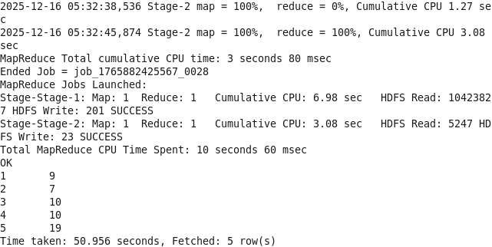
Appendix 11 Select games and count total reviews
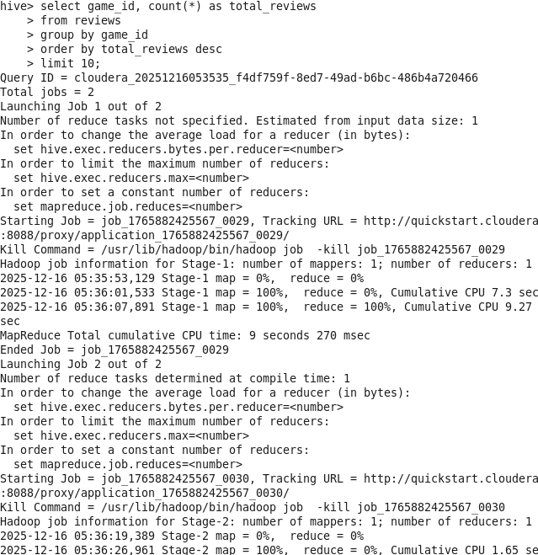
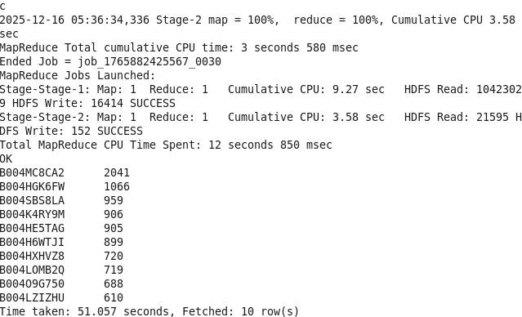
Appendix 12 Select games and average ratings and, count total reviews
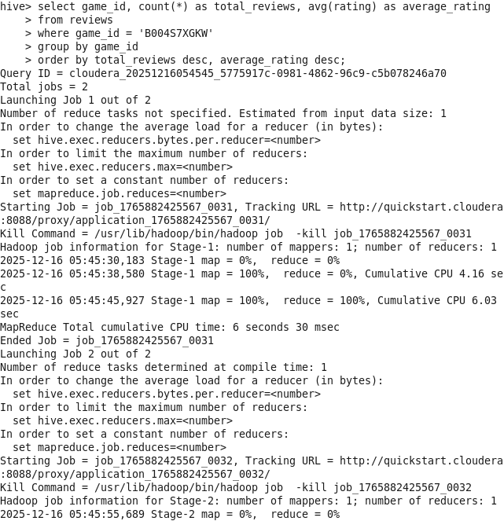

Appendix 13 Select games and sum one-star and five-star reviews
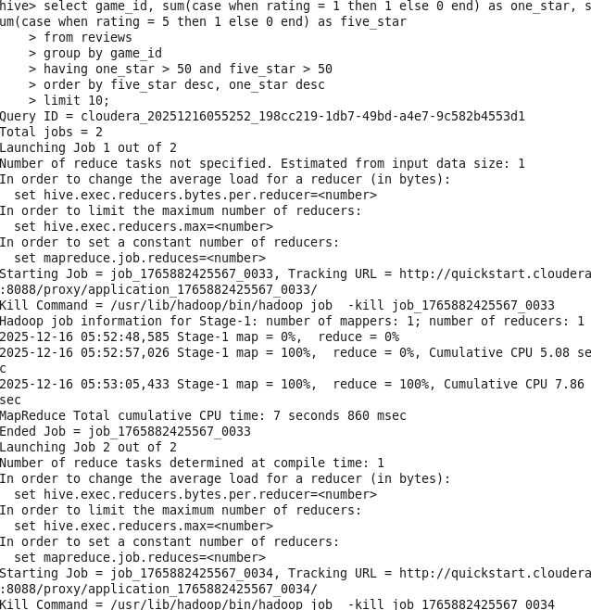
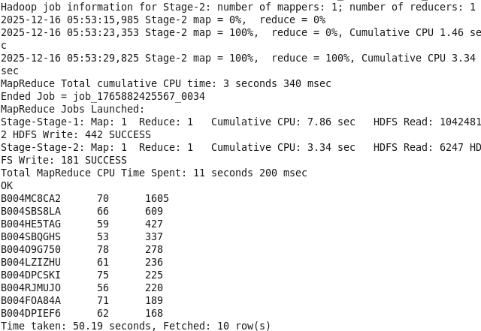
Appendix 14 Glimpse of road accident dataset
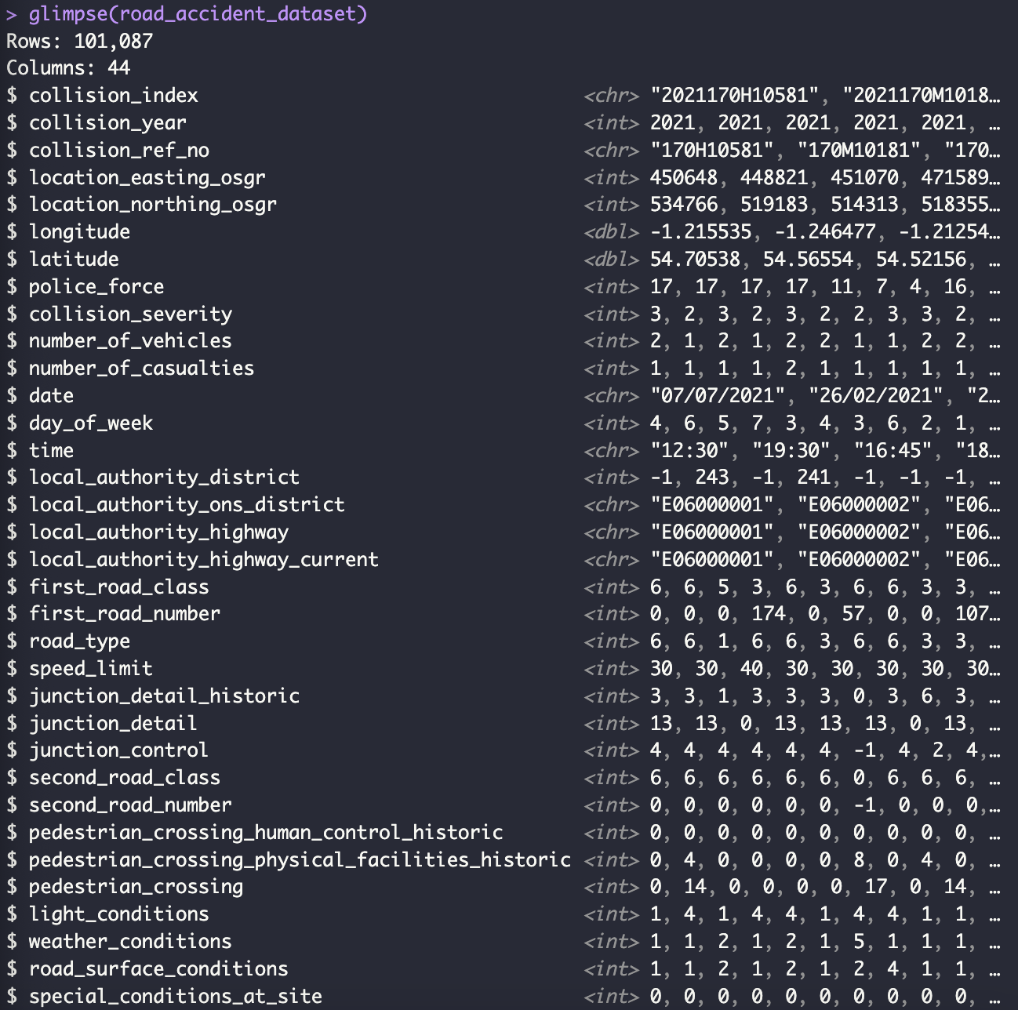
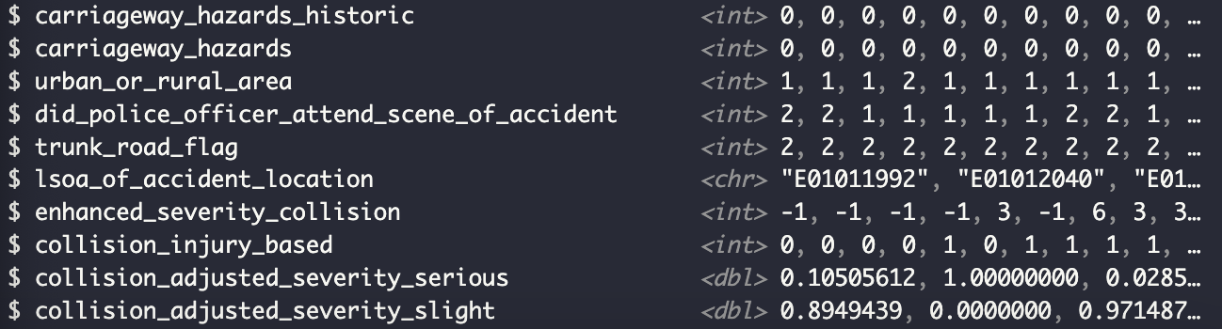

Appendix 15 Summary of road accident dataset
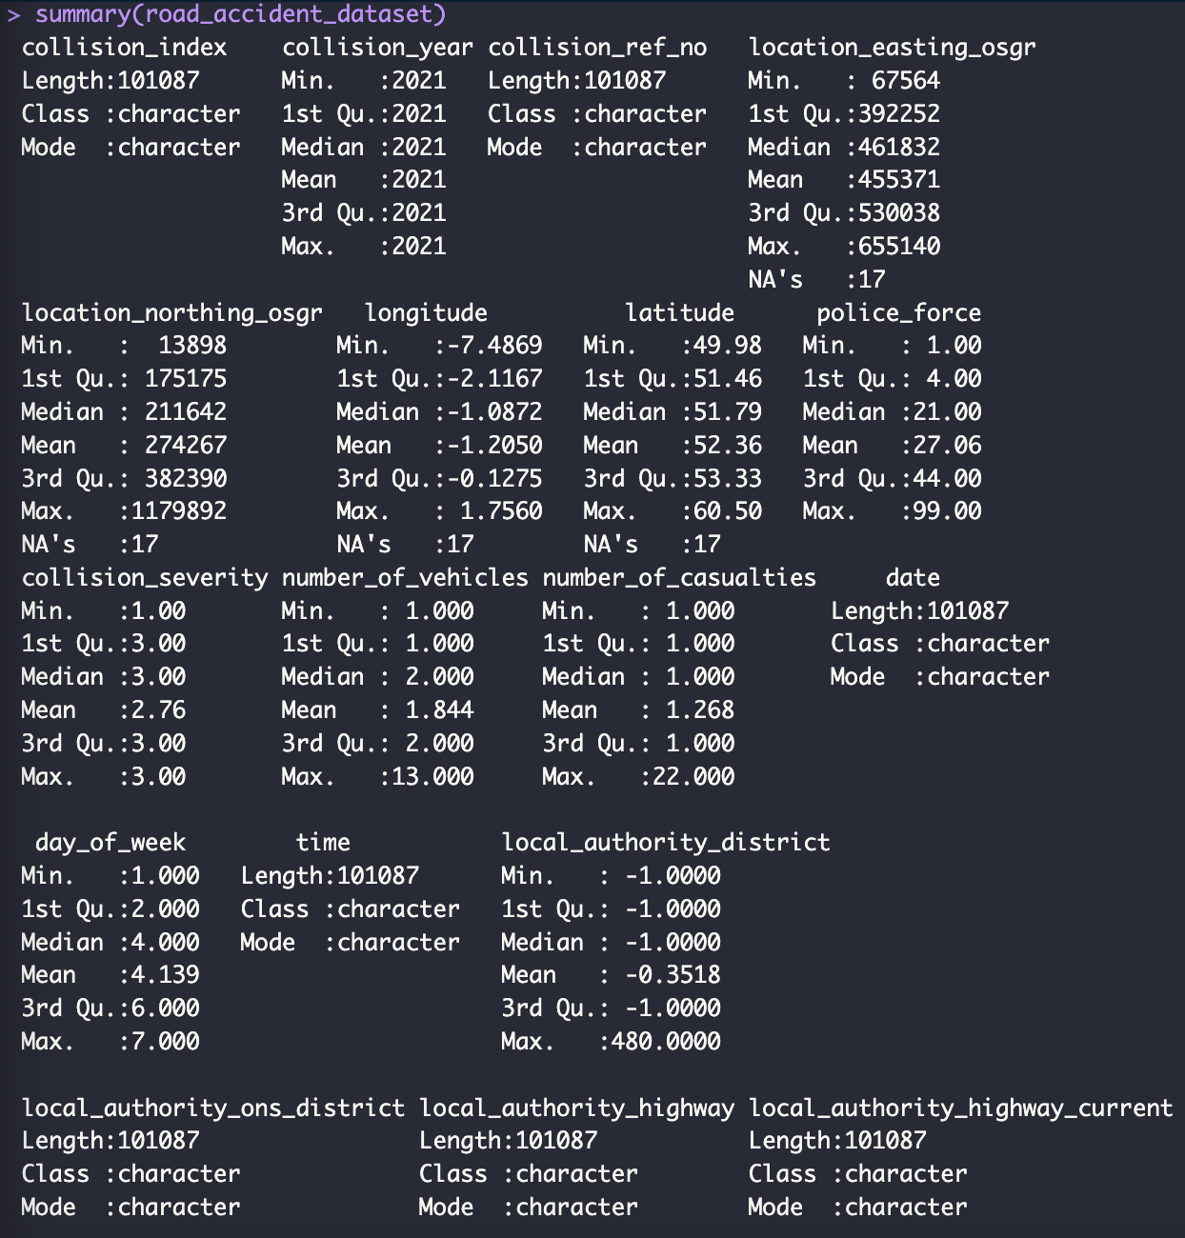
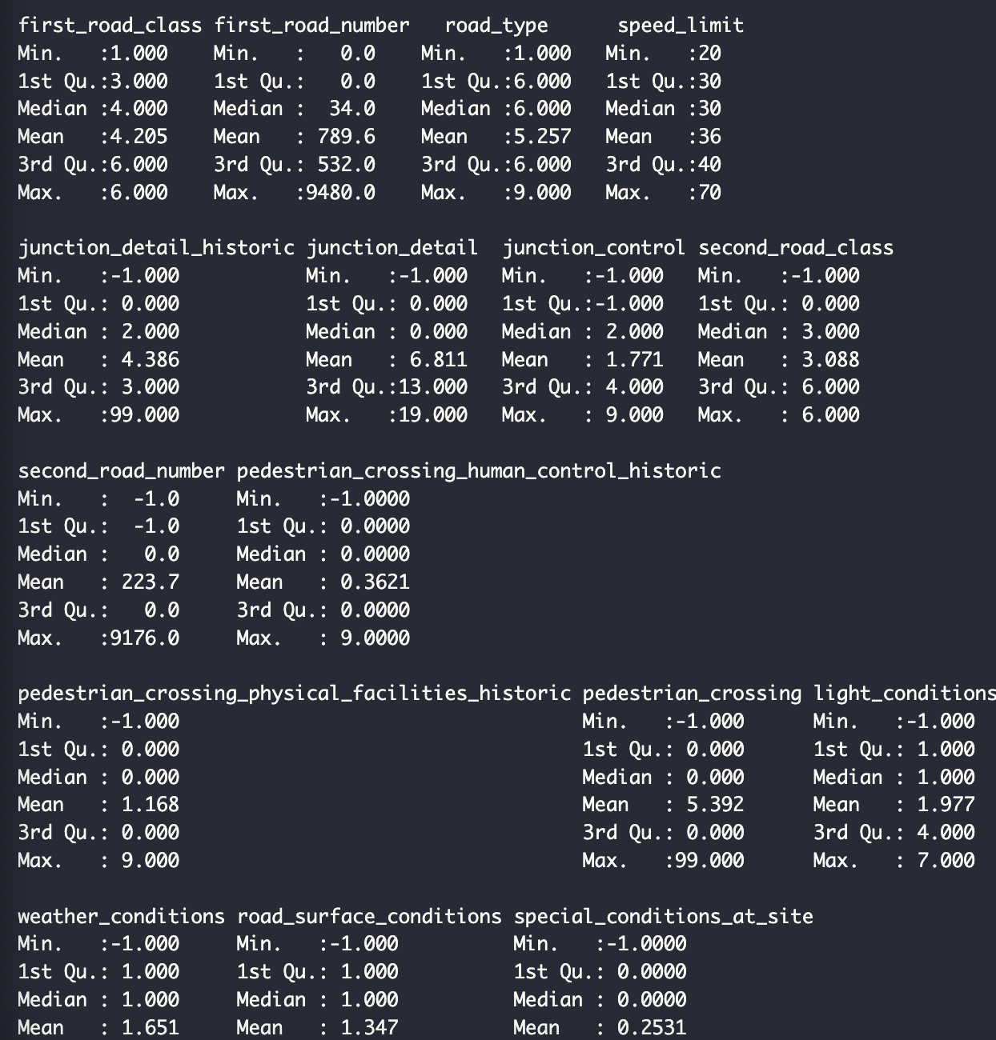
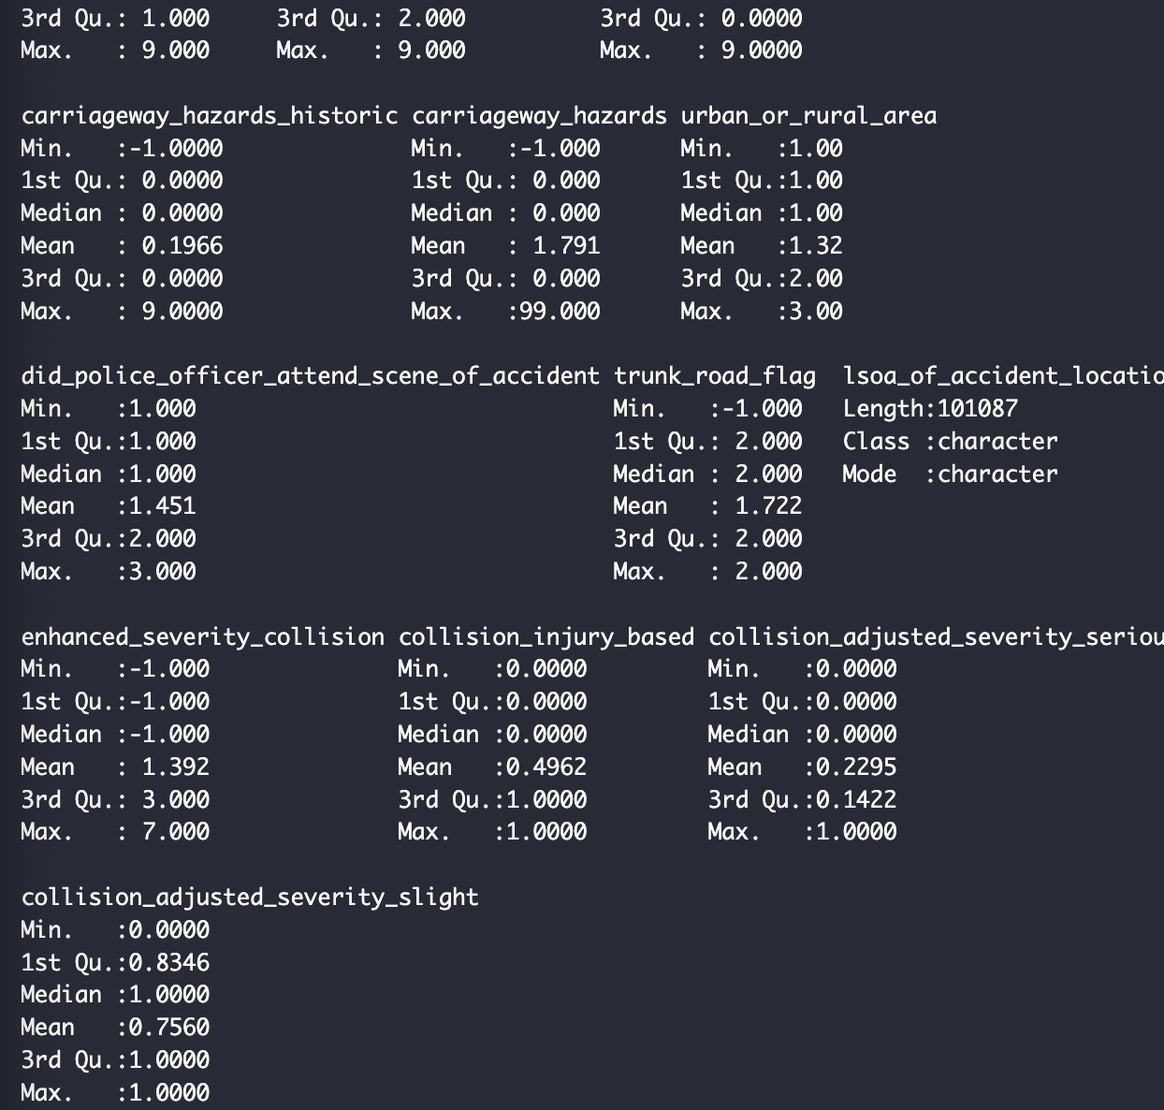
Appendix 16 Head of road accident dataset
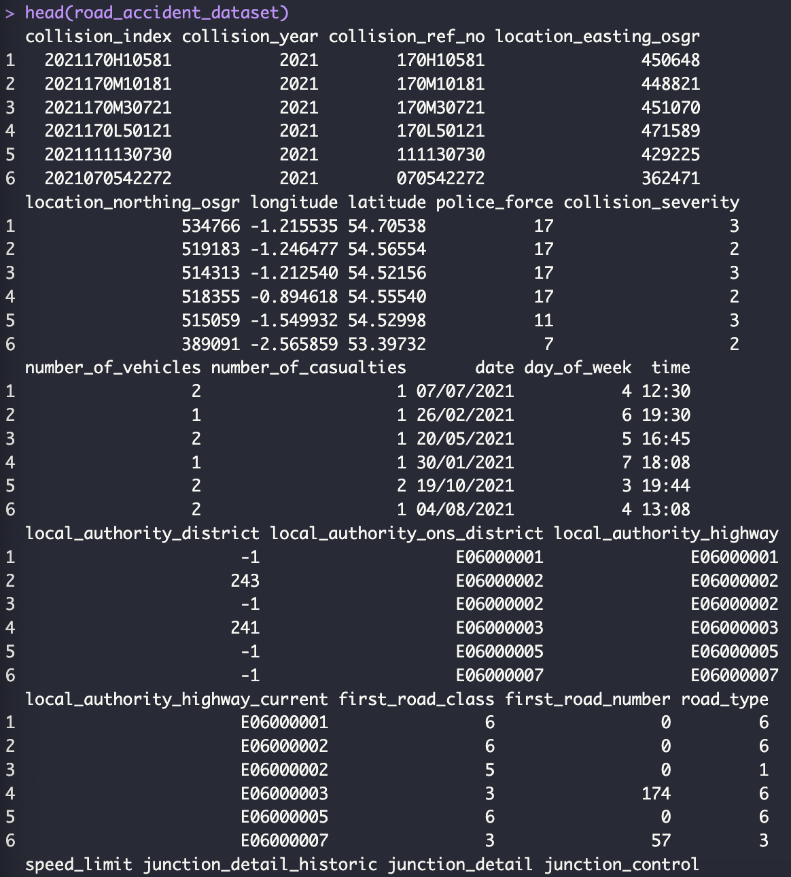
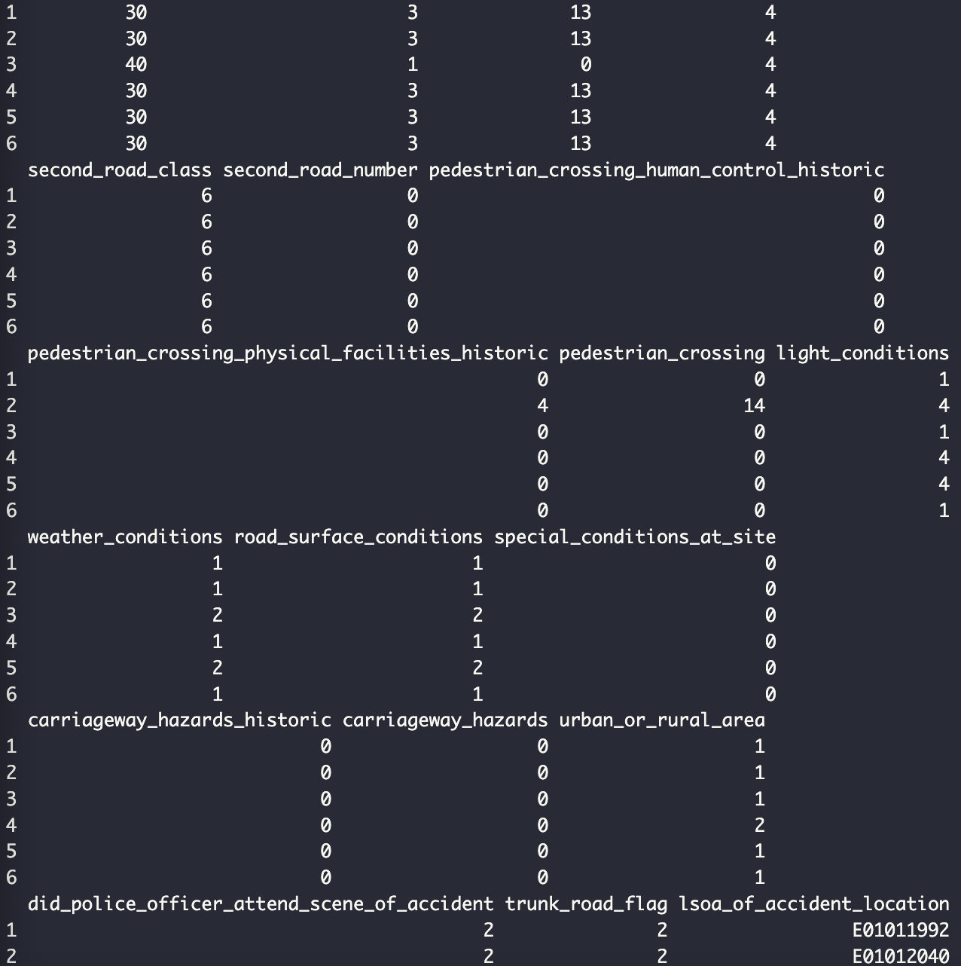
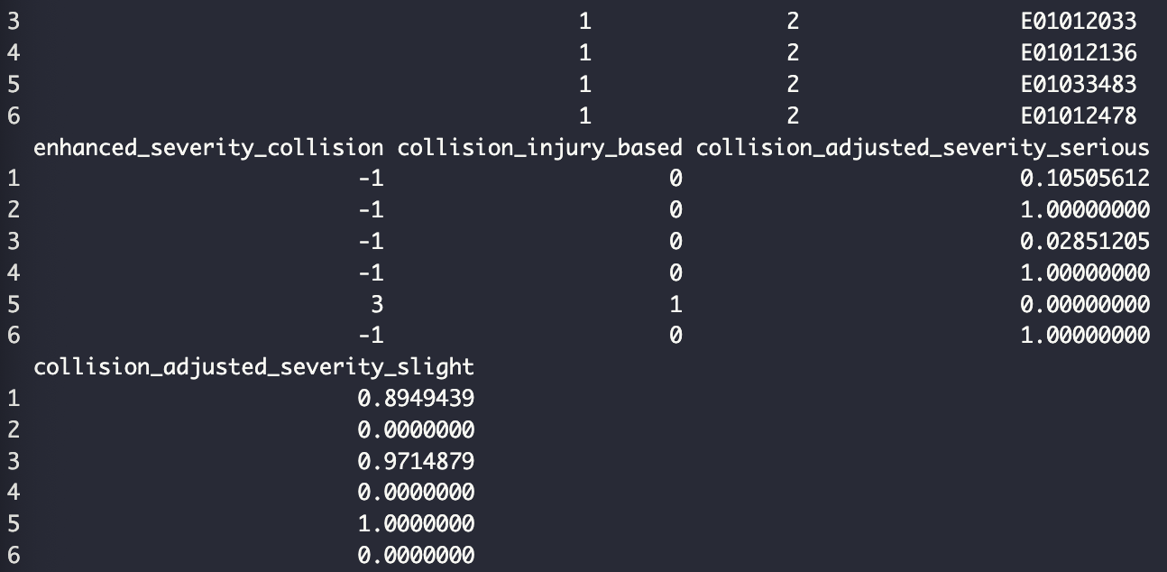
Appendix 17 Glimpse of vehicle dataset
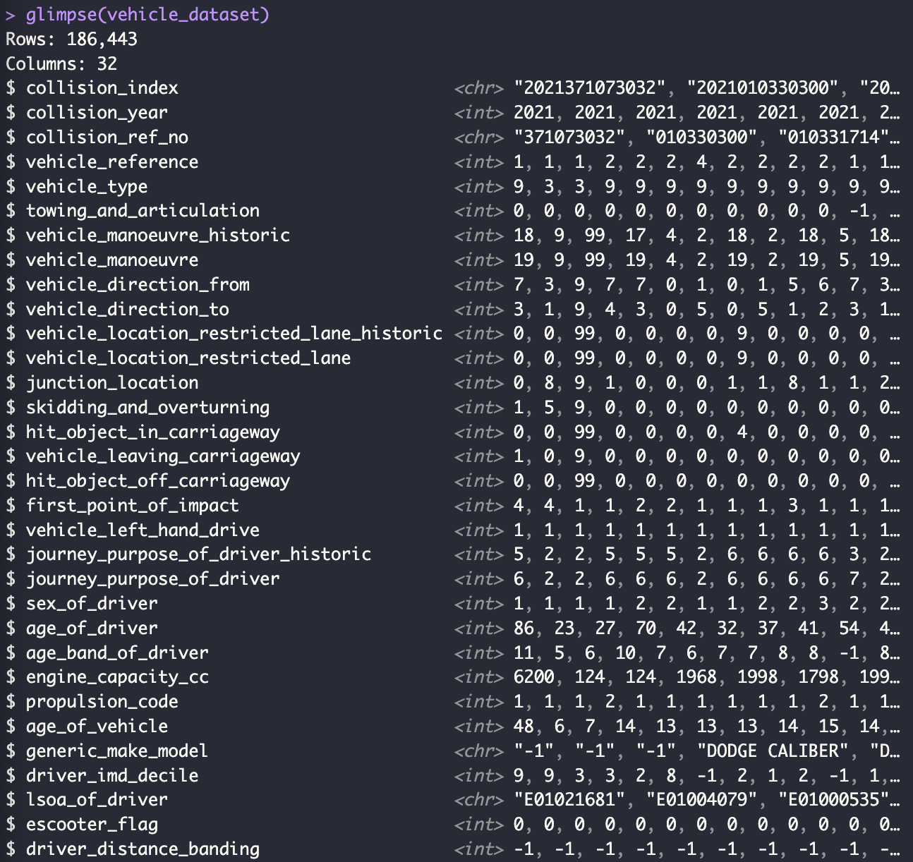

Appendix 18 Summary of vehicle dataset
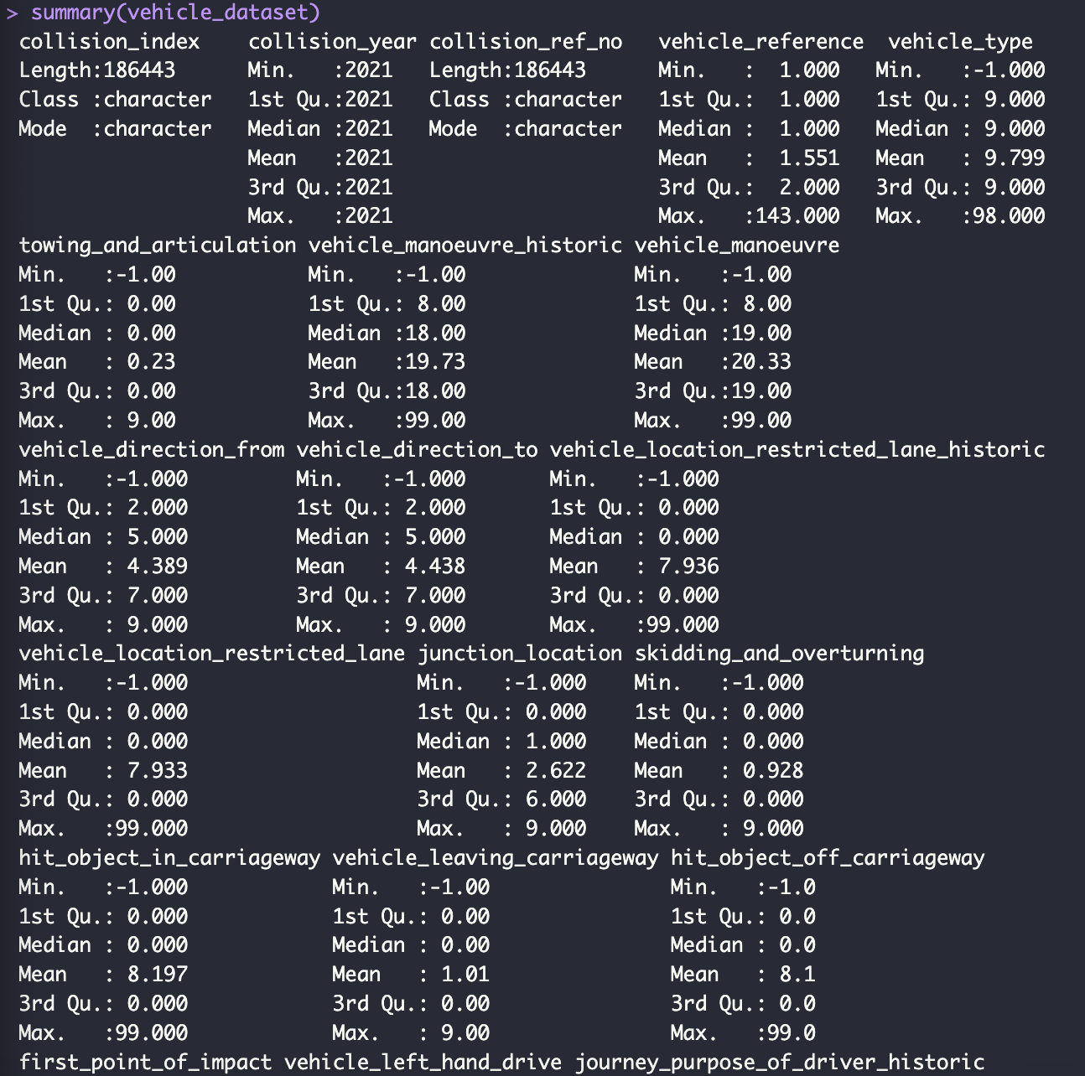
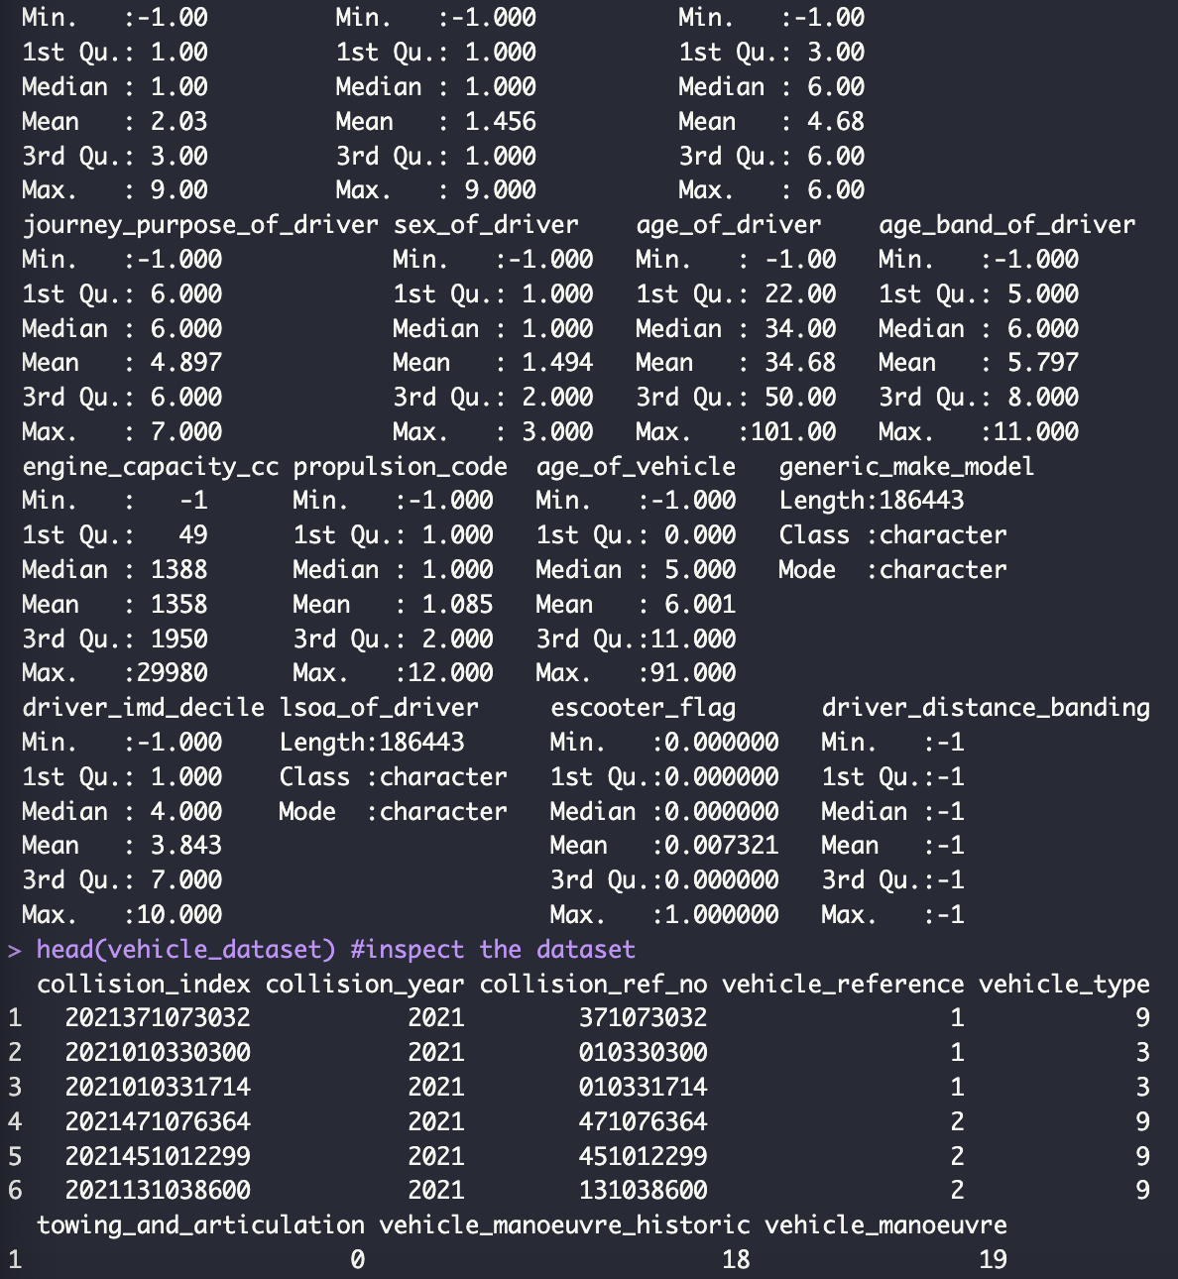
Appendix 19 Head of vehicle dataset
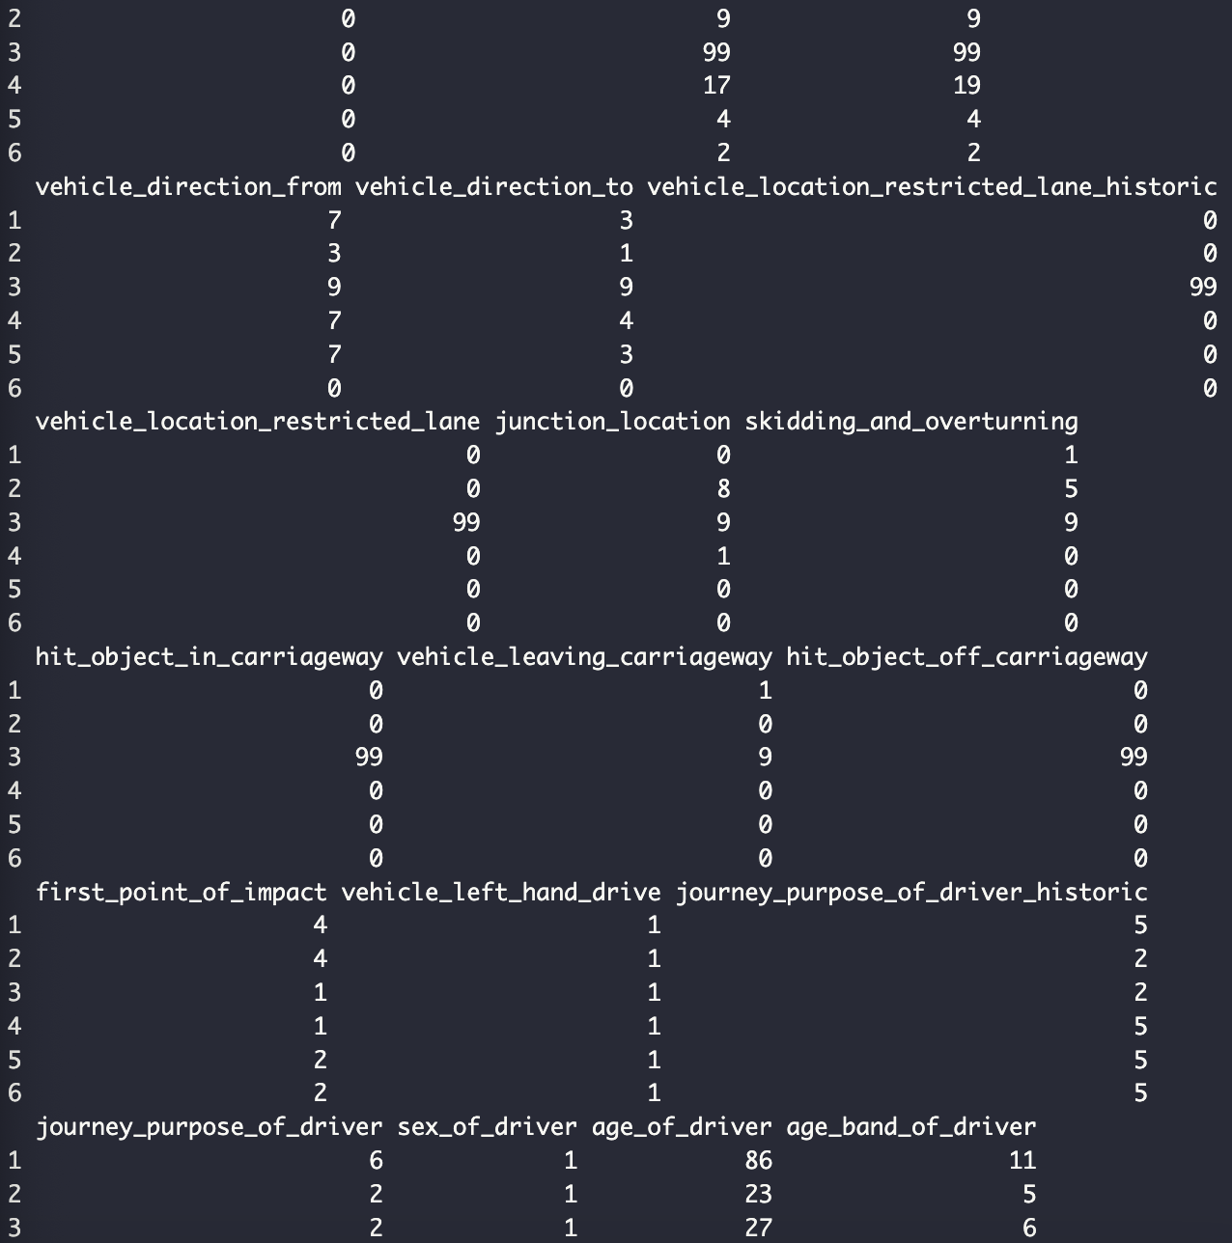
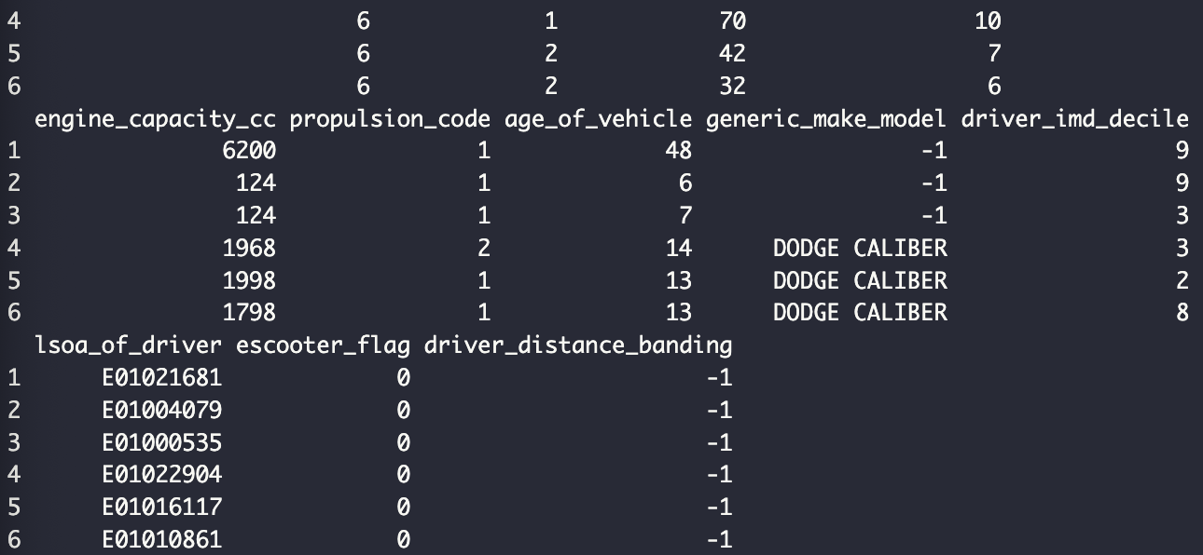
Appendix 20 Head of accident vehicle metrics



